Resolution proof thou should^{st} know^{st}:

If p ∨ r and ¬p ∨ q are both true then ___ q ∨ r _______ is also true
If p and ¬p ∨ q are both true then ____ q ______ is also true
If ¬p and p ∨ r are both true then _____ r __ is also true
Rewrite ¬(ab) as a clause - ¬a ∨ ¬b
Rewrite (a ∨ bc) as a clause - (a ∨ b) (a ∨ c) - two separate lines/clauses

1) m ∨ ¬n  2) ¬m ∨ q 1) and 2) → ¬n ∨ q  3) n_____ above and 3) → q  ∴q | 1) ¬p ∨ t  2) ¬q ∨ s  3) ¬r ∨ st  4) p ∨ q ∨ r ∨ u  ∴ s ∨ t ∨ u  3) → ¬r ∨ s and ¬r ∨ t  4) & ¬r ∨ s → p ∨ q ∨ u ∨ s  1) & p ∨ q ∨ u ∨ s → t ∨ q ∨ u ∨ s  2) & t ∨ q ∨ u ∨ s → t ∨ u ∨ s

Consider Ackerman’s Function shown below
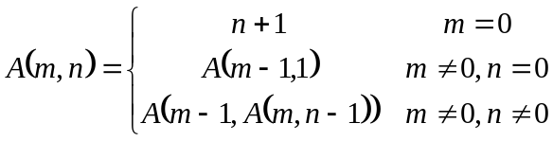 | Prove the following property of Ackerman’s Function by induction.  *Assume m > 0 & n > 0

First prove: 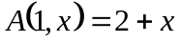  x=0: A(1,0) = A(0, 1) = 1+1 = 2 = 2 + 0 ☺  Assume 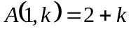  show 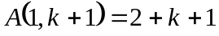  A(1,k+1) = A(0, A(1,k))  = A(1,k) + 1 = 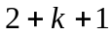 ☺ | Then prove: 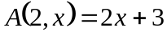  Hint: Yes, you may (should) use the results of previous property/proof  x=0: A(2,0) = A(1, 1) = 2+1 = 3 = 2*0 + 3 ☺  Assume 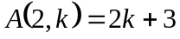  show 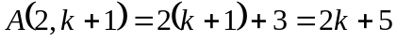  = A(1,A(2,k)) = A(1,2k+3))  = 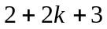 = 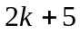 ☺

Prove 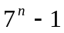 is divisible by 6.  n=1, 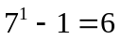which is divisible by 6. ☺  Assume 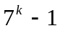 is divisible by 6  Show 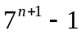 is divisible by 6  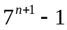 = 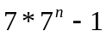  = 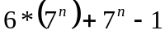  Both terms are divisible by 6,  ∴ sum is divisible by 6 ☺  And is divisible by 6. | Prove 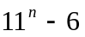 is divisible by 5.  n=1, 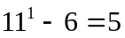which is divisible by 5. ☺  Assume 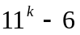 is divisible by 5  Show 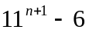 is divisible by 5  = 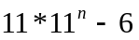  = 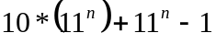  Both terms are divisible by 5,  ∴ sum is divisible by 5 ☺  And 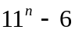 is divisible by 5.

Given 3-cent and 7-cent stamps, for what value of n can you prove that amount of postage that is at least n-cents can be made from 3-cent and 7-cent stamps? Prove it!

6, 7, 8, 9, 10, 11, 12(4*3), 13(2*3+1*7), 14(2*7).
Show all postage that is at least 12-cents can be made.

Already shown for n=12, 13, 14, 15. Assume true of 12 < k < n.

Show true for n. Postage n-3 cents is possible by inductive assumption. Add 3-cent stamp to make
n-cent stamp.

Prove by Induction
1² + 2² + ... + n² = (n)(n+1)(2n+1)/6  Show true for n = 1  1² = (1)(1+1)(2*1+1)/6 ?  1 = 1*2*3 / 6 = 1 ☺  Assume true for n = k  1² + 2² + ... + k² = (k)(k+1)(2k+1)/6  Show true for n = k + 1, i.e.  1² + 2² + ... + k² + (k+1)²  = (k+1)(k+1+1)(2(k+1)+1)/6  or  1² + 2² + ... + k² + (k+1)²  = (k+1)(k+2)(2k+3)/6  1² + 2² + ... + k² + (k+1)² =  = (k)(k+1)(2k+1)/6 + (k+1)²  = (k)(k+1)(2k+1)/6 + 6(k+1)²/6  = {(k)(2k+1) + 6(k+1)} (k+1)/6  = {2k²+7k+6} (k+1)/6  = (k+1)(k+2)(2k+3)/6 ☺ | If 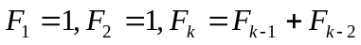,  then 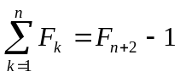  Show true for n = 1  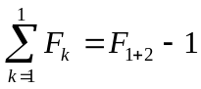 ?  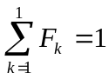 & 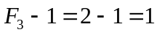 ☺  Assume true for n = k  Show true for n = k + 1, i.e.  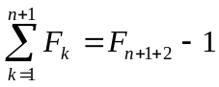  or  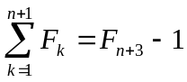  = 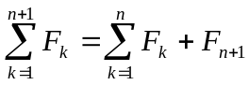  = 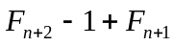  But    

